All the things that affect the final output are:

the position of the light, cone angle, smooth angle, cone direction, ambient material, ambient intensity, diffuse material, diffuse intensity, specular material, specular intensity, shininess, and attenuation coeff.

1. For direct light, the light position is actually the light direction. Only the direction of the light affect the appearance in the direct light.

For spot light, the light position decide the distance between the sphere and light. As the distance increase, the brightness decrease, but the bright area increase.

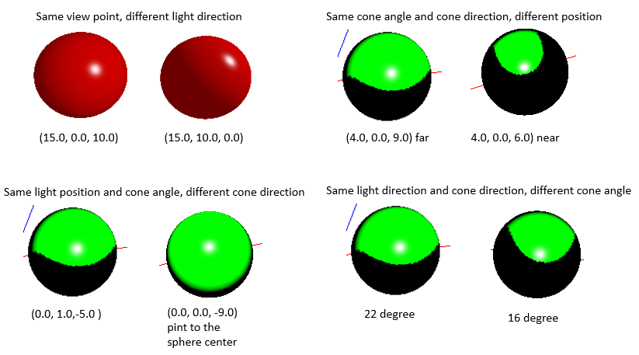

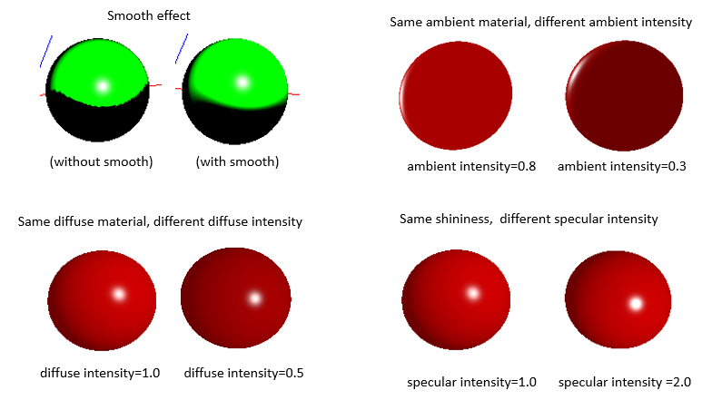

1. Cone angle decided the size of the lighted area by the spotlight; the larger the cone angle, the larger the area. The cone direction decided the direction of the spotlight, thus the lighted area. The smooth angle provide a smooth transient between lighted and unlighted area.
2. The ambient material decide the color of sphere, especially the unlighted area, and as the ambient intensity decreased, the color became darker.
3. Diffuse material decide the color of the lighted area, both in direct light and spot light. As the diffuse intensity decreased, the color became darker.
4. The specular material is always (1.0,1.0,1.0), because it is mirror reflective. As the specular intensity decreased, the specular area became darker. The shininess affect the size of the specular spot. As the shininess increased, the size of the specular spot decrease.
5. Attenuation coeff affect color of the lighted area, as

attenuation = 1.0 / (1.0 + attenuationCoefficient * pow(distanceToLight, 2)), and linearColor = out_ambient_color + attenuation * ( out_diffuse_color + out_specular_color);

With small Attenuation coeff, the color in the lighted area is dominated by the diffuse color and specular color; with large Attenuation coeff, the color in the lighted area is dominated by the ambient color.

